**Project Xamarindos Games**

Index

* Descriptions of the Application
* TODO and improvements list
* Experiences developing this app

**Description of the Application**

This app is a Xamaring.Form application, consist of different pages and views elements.

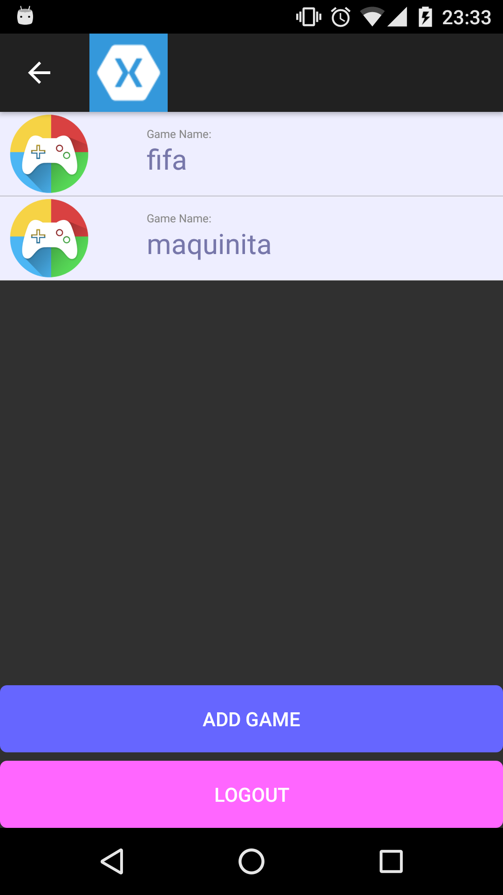

The first page that we found is, the **logging page**, here the user has to introduce its credentials, and if all go right, or create an account, you can press the **CREATE** button and fill the fields, when you finish this process, you will be redirect to **Main Page**, here, in this view, we can find a list of games, (I added a image that represent the game, instead of only the string) you can select some of this items or inclusively add a new game, for the moment Delete is not supported but the application has context actions, you just need to let an item selected for some seconds you could and the context action took place.

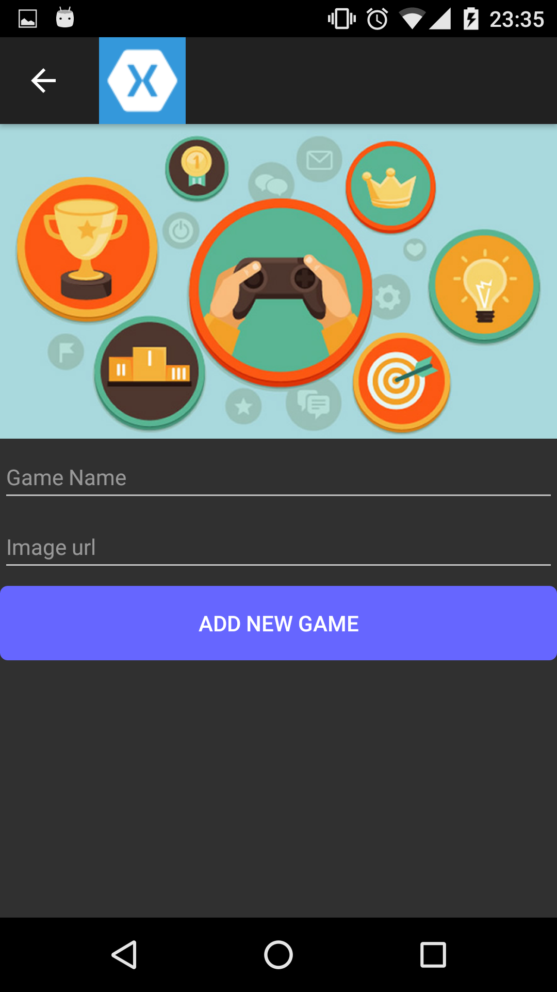

if you give a touch over an item you could be redirect to another page, here you could find a list of player that have played the selected game, there are two buttons in this page, "**ADD NEW GAME and BEST PLAYER".**

**BEST PLAYER** redirect you to the page of the players with the best score ordered from the best to the worst, this list isn't finished yet, it isn't show the winners or the losers with the corresponding color.

**ADD NEW GAME** give you the chance of add a new match.

* **TODO and improvements list**
  + Implement Singleton pattern in ServerOperationManager
  + Implement Delete on Game list
  + Improve design of Best Players page
  + Implement Logout
  + Show amount of matches won or lost
  + Test in IOS devices( I am really sorry, I could get one of this device to make some test)

**Experiences developing this app**

I really enjoy doing this app, I know that it isn't finished yet, but I learned a lot of things about Xamarin.forms and web services, it was a great experience, I add some extra functionalities to the app, I always try to give my best.

I just want to thank you for your time, see you then.

Best Regards,

Armando